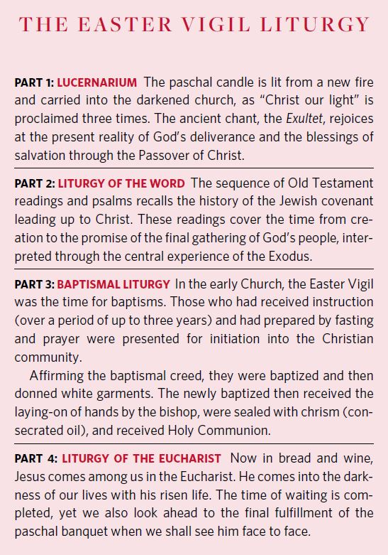
First Part:
The Solemn Beginning of the Vigil or Lucernarium
The Blessing of the Fire and Preparation of the Candle

8 & 13. (pp, adapt.) A blazing fire is prepared at the front steps of the church. The people are gathered in the church as on other occasions.
The people turn to face the rear doors of the church.
The Priest approaches the fire with the Deacon, who holds the paschal candle.

9. The Priest and faithful sign themselves while the Priest says:

In the name of the Father, and of the Son, and of the Holy Spirit,

and then he greets the assembled people in the usual way
and briefly instructs them about the night vigil in these or similar words:

Dear brothers and sisters,
on this most sacred night,
in which our Lord Jesus Christ
passed over from death to life,
the Church calls upon her sons and daughters,
scattered throughout the world,
to come together to watch and pray.
If we keep the memorial
of the Lord’s paschal solemnity in this way,
listening to his word and celebrating his mysteries,
then we shall have the sure hope
of sharing his triumph over death
and living with him in God.

10. Then the Priest blesses the fire, saying with hands extended:

Let us pray.
O God, who through your Son
bestowed upon the faithful the fire of your glory,
sanctify X this new fire, we pray,
and grant that,
by these paschal celebrations,
we may be so inflamed with heavenly desires,
that with minds made pure
we may attain festivities of unending splendor.
Through Christ our Lord.
R. Amen.

11. After the blessing of the new fire, one of the ministers brings the paschal candle to the Priest, who cuts a cross into the candle with a stylus. Then he makes the Greek letter Alpha above the cross, the letter Omega below, and the four numerals of the current year between the arms of the cross, saying meanwhile:

1. Christ yesterday and today
(he cuts a vertical line);
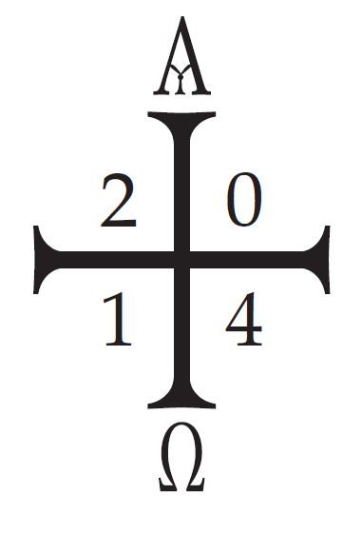
2. the Beginning and the End
(he cuts a horizontal line);
3. the Alpha
(he cuts the letter Alpha above the vertical line);
4. and the Omega
(he cuts the letter Omega below the vertical line).
5. All time belongs to him
2
1
(he cuts the first numeral of the current year in
the upper left corner of the cross);
6. and all the ages
(he cuts the second numeral of the current year in
the upper right corner of the cross).
7. To him be glory and power
(he cuts the third numeral of the current year in
the lower left corner of the cross);
8. through every age and for ever. Amen.
(he cuts the fourth numeral of the current year in
the lower right corner of the cross).

12. When the cutting of the cross and of the other signs has been completed, the Priest may insert five grains of incense into the candle in the form of a cross, meanwhile saying:

1. By his holy
2. and glorious wounds,
3. may Christ the Lord
4. guard us
5. and protect us. Amen.

The Priest or Deacon lights the Paschal candle from the Easter fire.

The Priest says:
May the light of Christ rising in glory
dispel the darkness of our hearts and minds.

15. (pp, adapt.) When the candle has been lit, one of the ministers takes burning coals from the fire and places them in the thurible, and the Priest puts incense into it in the usual way.

13. (pp, adapt.) The Priest comes to the door of the church, along with the thurifer and the Deacon carrying the paschal candle.

Procession
15. (pp, adapt.) The Deacon takes the paschal candle. The thurifer with the smoking thurible precedes the Deacon who carries the paschal candle. After them follows the Priest, holding in his hands an unlit candle.

At the door of the church the Deacon, raising up the candle, sings:
Lumen Christi. Light of Christ.
And all reply:
Deo Gratias. Thanks be to God.

The Priest lights his candle from the flame of the paschal candle.

16. Then the Deacon moves forward to the middle of the church and, standing and raising up the candle, sings a second time:
Lumen Christi. Light of Christ.
And all reply:
Deo Gratias. Thanks be to God.

All light their candles from the flame of the paschal candle.
17. When the Deacon arrives before the altar, he stands facing the people, raises up the candle and sings a third time:
Lumen Christi. Light of Christ.
And all reply:
Deo Gratias. Thanks be to God.
Then the Deacon places the paschal candle on a large candle stand prepared next to the ambo.

The thurifer brings the thurible to the Priest, who places incense in the thurible.
The thurifer brings the thurible to the Deacon who incenses the Paschal Candle.

The Deacon and thurifer move to their places in the sanctuary.

The cantor sings the Exultet.

Fr. Vitus will sing “The Lord be with you” through “Let us give thanks to the Lord, our God.”
The Easter Proclamation
(Exsultet)
18. (pp, adapt.)
The blessing of the Deacon is omitted if the Proclamation is made by someone who is not a Deacon.
19. (pp, adapt.) The Easter Proclamation may be made by a lay cantor.
The greeting “The Lord be with you. Lift up your hearts. Let us give thanks to the Lord, our God.” will be sung by the Priest.
The Proclamation may be sung in the shorter form (pp. 357-361).

Shorter Form of the Easter Proclamation

CANTOR:
Exult, let them exult, the hosts of heaven,
exult, let Angel ministers of God exult,
let the trumpet of salvation
sound aloud our mighty King’s triumph!
Be glad, let earth be glad, as glory floods her,
ablaze with light from her eternal King,
let all corners of the earth be glad,
knowing an end to gloom and darkness.
Rejoice, let Mother Church also rejoice,
arrayed with the lightning of his glory,
let this holy building shake with joy,
filled with the mighty voices of the peoples.

FR. VITUS: 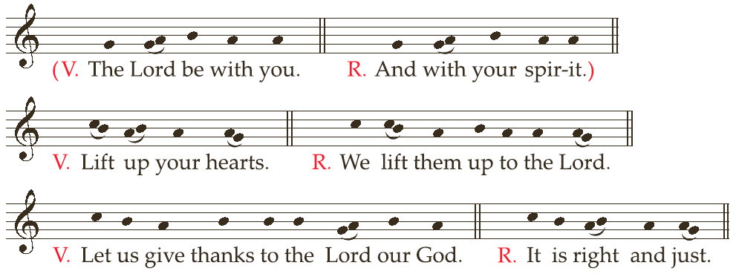

CANTOR:
It is truly right and just,
with ardent love of mind and heart
and with devoted service of our voice,
to acclaim our God invisible, the almighty Father,
and Jesus Christ, our Lord, his Son, his Only Begotten.
Who for our sake paid Adam’s debt to the eternal Father,
and, pouring out his own dear Blood,
wiped clean the record of our ancient sinfulness.
These then are the feasts of Passover,
in which is slain the Lamb, the one true Lamb,
whose Blood anoints the doorposts of believers.
This is the night,
when once you led our forebears, Israel’s children, from slavery in Egypt
and made them pass dry-shod through the Red Sea.
This is the night that with a pillar of fire banished the darkness of sin.
This is the night that which even now, throughout the world,
sets Christian believers apart from worldly vices
and from the gloom of sin, leading them to grace and joining them to his holy ones.
This is the night,
when Christ broke the prison-bars of death and rose victorious from the underworld.
O wonder of your humble care for us!
O love, O charity beyond all telling, to ransom a slave you gave away your Son!
O truly necessary sin of Adam,
destroyed completely by the Death of Christ!
O happy fault that earned so great, so glorious a Redeemer!
The sanctifying power of this night dispels wickedness, washes faults away,
restores innocence to the fallen, and joy to mourners.
O truly blessed night,
when things of heaven are wed to those of earth and divine to the human.
On this, your night of grace, O holy Father,
accept this candle, a solemn offering,
the work of bees and of your servants’ hands,
an evening sacrifice of praise,
this gift from your most holy Church
Therefore, O Lord, we pray you that this candle,
hallowed to the honor of your name, may persevere undimmed,
to overcome the darkness of this night.
Receive it as a pleasing fragrance,
and let it mingle with the lights of heaven.
May this flame be found still burning
by the Morning Star: the one Morning Star who never sets,
Christ your Son,
who, coming back from death’s domain,
has shed his peaceful light on humanity,
and lives and reigns for ever and ever.

R. Amen.
Second Part:
The Liturgy of the Word

After setting aside their candles, all sit. Before the readings begin, the Priest instructs the
people in these or similar words:

Dear brothers and sisters,
now that we have begun our solemn Vigil,
let us listen with quiet hearts to the Word of God.
Let us meditate on how God in times past saved his people
and in these, the last days, has sent us his Son as our Redeemer.
Let us pray that our God may complete this paschal work of salvation
by the fullness of redemption.

Prayers after the Readings

Genesis Reading – Lectors and Music Ministry

24. After the first reading (On creation: Gn 1: 1–2: 2 or 1: 1, 26-31a)
Let us pray.
Almighty ever-living God,
who are wonderful in the ordering of all your works,
may those you have redeemed understand
that there exists nothing more marvelous
than the world’s creation in the beginning
except that, at the end of the ages,
Christ our Passover has been sacrificed.
Who lives and reigns for ever and ever.
R. Amen.
Exodus Reading – Music Ministry

26. After the third reading (On the passage through the Red Sea: Ex 14: 15-15: 1) and its canticle (Ex 15).
Let us pray.
O God, whose ancient wonders
remain undimmed in splendor even in our day,
for what you once bestowed on a single people,
freeing them from Pharaoh’s persecution
by the power of your right hand
now you bring about as the salvation of the nations
through the waters of rebirth,
grant, we pray, that the whole world
may become children of Abraham
and inherit the dignity of Israel’s birthright.
Through Christ our Lord.
R. Amen.

Isaiah Reading – Lector and Music Ministry

28. After the fifth reading (On salvation freely offered to all: Is 55: 1-11) and the canticle (Is 12).
Let us pray.
Almighty ever-living God,
sole hope of the world,
who by the preaching of your Prophets
unveiled the mysteries of this present age,
graciously increase the longing of your people,
for only at the prompting of your grace
do the faithful progress in any kind of virtue.
Through Christ our Lord.
R. Amen.
Altar candles are lit. - Lights are turned on. - Bells are rung.
31. After the last reading from the Old Testament with its Responsorial Psalm and its prayer, the
altar candles are lit, and the Priest intones the hymn Gloria in excelsis Deo (Glory to God in the highest), which is taken up by all, while bells are rung, according to local custom.

32. When the hymn is concluded, the Priest says the Collect in the usual way.
Let us pray.
O God, who make this most sacred night radiant
with the glory of the Lord’s Resurrection,
stir up in your Church a spirit of adoption,
so that, renewed in body and mind,
we may render you undivided service.
Through our Lord Jesus Christ, your Son,
who lives and reigns with you in the unity of the Holy Spirit,
one God, for ever and ever.

33. Then the reader proclaims the reading from the Apostle.
Reading of the Epistle – Lector

34. After the Epistle has been read, all rise, then the Priest solemnly intones the Alleluia three
times, raising his voice by a step each time, with all repeating it. If necessary, the psalmist
intones the Alleluia.
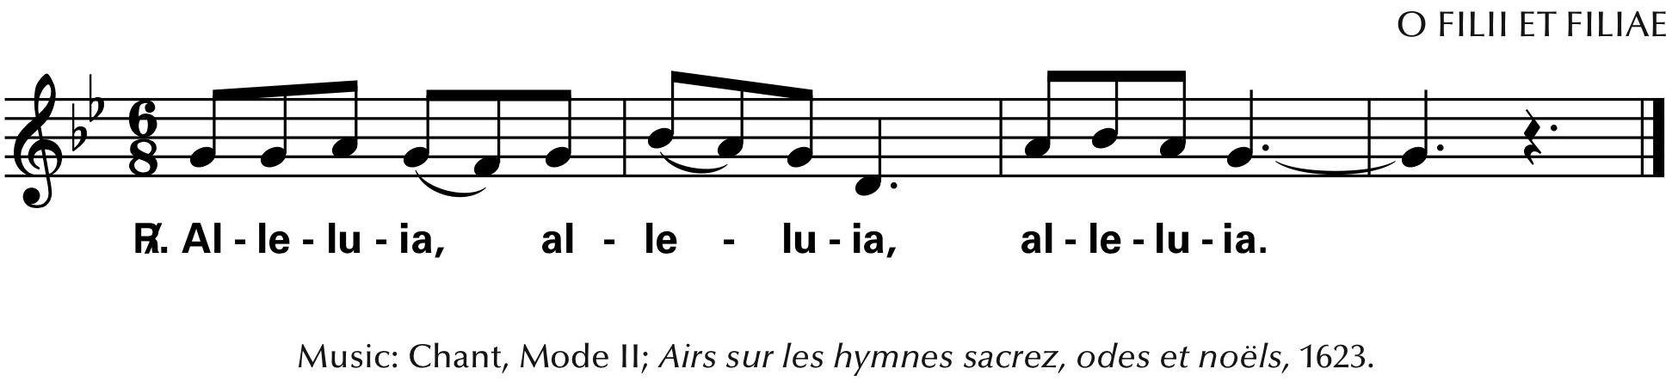

Then the psalmist or cantor proclaims Psalm 118 (117) with the people responding Alleluia.

35. The Priest, in the usual way, puts incense in the thurible and blesses the Deacon. At the
Gospel lights are not carried, but only incense.

36. After the Gospel, the Homily, even if brief, is not to be omitted.
Gospel and Homily
Third Part:

Baptismal Liturgy
The Blessing of Water

54. If no one present is to be baptized and the font is not to be blessed, the Priest introduces the
faithful to the blessing of water, saying:

Dear brothers and sisters,
let us humbly beseech the Lord our God
to bless this water he has created,
which will be sprinkled upon us
as a memorial of our Baptism.
May he graciously renew us,
that we may remain faithful to the Spirit
whom we have received.

And after a brief pause in silence, he proclaims the following prayer,
with hands extended:

Lord our God,
in your mercy be present to your people
who keep vigil on this most sacred night,
and, for us who recall the wondrous work of our creation
and the still greater work of our redemption,
graciously bless this water.
For you created water to make the fields fruitful
and to refresh and cleanse our bodies.
You also made water the instrument of your mercy:
for through water you freed your people from slavery
and quenched their thirst in the desert;
through water the Prophets proclaimed the new covenant
you were to enter upon with the human race;
and last of all,
through water, which Christ made holy in the Jordan,
you have renewed our corrupted nature
in the bath of regeneration.
Therefore, may this water be for us
a memorial of the Baptism we have received,
and grant that we may share
in the gladness of our brothers and sisters,
who at Easter have received their Baptism.
Through Christ our Lord.
R. Amen.

The Renewal of Baptismal Promises

55. (pp, adapt) After the blessing of water, all stand, holding lighted candles in their hands, and renew the promise of baptismal faith.

The Priest addresses the faithful in these or similar words:
Dear brothers and sisters, through the Paschal Mystery
we have been buried with Christ in Baptism,
so that we may walk with him in newness of life.
And so, now that our Lenten observance is concluded,
let us renew the promises of Holy Baptism,
by which we once renounced Satan and his works
and promised to serve God in the holy Catholic Church.

And so I ask you:
Priest: Do you renounce Satan?
All: I do.
Priest: And all his works?
All: I do.
Priest: And all his empty show?
All: I do.

Then the Priest continues:

Priest: Do you believe in God,
the Father almighty,
Creator of heaven and earth?
All: I do.
Priest: Do you believe in Jesus Christ, his only Son, our Lord,
who was born of the Virgin Mary,
suffered death and was buried,
rose again from the dead
and is seated at the right hand of the Father?
All: I do.
Priest: Do you believe in the Holy Spirit,
the holy Catholic Church,
the communion of saints,
the forgiveness of sins,
the resurrection of the body,
and life everlasting?
All: I do.

And the Priest concludes:
And may almighty God, the Father of our Lord Jesus Christ,
who has given us new birth by water and the Holy Spirit
and bestowed on us forgiveness of our sins,
keep us by his grace,
in Christ Jesus our Lord,
for eternal life.
All: Amen.

56. The Priest sprinkles the people with the blessed water, while all sing.
(Another chant that is baptismal in character may also be sung.)

Song: We shall Draw Water (refrain only, repeat as needed for the Priest to sprinkle briefly from the front and then ascend to the chair.)

58. (pp, adapt.) After the sprinkling, the Priest returns to the chair where, omitting the Creed, he directs the Universal Prayer.

