In Gratitude to God for every blessing of every day, the Christian Churches of Ronkonkoma gather in worship and praise

Rev. Karen Burger Fr. Anthony Osuagwu
The Rev. Diane L. Neuls DeBlasio Deacon Bill Dobbins
Fr. Mike Rieder Deacon Matt Yellico

Order of Worship:
Prelude (on screens): Grateful
Gathering Song: For the Beauty of the Earth #609, Journeysongs
Call to Worship
Leader: Give thanks to the Lord for He is Good
Response: His mercy endures forever
Leader: Let the people of Israel say
Response: His mercy endures forever
Leader: Let all who stand in awe of the Lord say
Response: His mercy endures forever
Welcome, followed by prayer

Todas las lecturas en inglés se publicarán en español en las pantallas.

Psalm 92
Refrain: It is good to give thanks to the LORD,
to sing praise to your name, Most High

Before each of the readings the choir will lead the following mantra:
Listen, listen, listen to my heart song.
Listen, listen, listen to my heart song.
I will never forget you I will never forsake you.
I will never forget you I will never forsake you.
Stand
Alleluia
Gospel: Mt 24:32-40
After the gospel is read in both English and Spanish, please be seated
Después de que se lea el evangelio en inglés y en español, siéntense

Thanksgiving Reflection

Let There Be Peace on Earth led by young people’s choir

Profession of Faith* (led by choir)
*Response: Amen! Amen! Amen! Amen! Amen, we do believe!

Please be seated
Reflection Song: The House that Love is Building (Sarah Hart)

Sharing of Peace

Offering Song: Hold On to Love (Jesse Manibusan)
During this song, there is a collection to serve those in need in all our communities.

Intercessions: Cantor will lead us in our sung response:
Give us your peace, Oh God, give us your peace, your peace.
Danos tu paz, O Dios, danos tu paz, tu paz.

At end of intercessions, we pray together: God of Mercy and Love, help us to open our hearts to the healing presence of your Holy Spirit. Guide us, your disciples, to fulfill your dreams for us and all of creation. We ask this in the name of our risen Lord, Jesus the Christ. Amen.

Lord’s Prayer: recited in English, cantado en español
Padre nuestro, que estas en el cielo, santificado sea tu nombre;
Venga a nosotros, venga tu Reino; hágase tu voluntad así en la tierra como en el cielo. El pan danos hoy, nuestro pan de cada día; Perdona nuestras ofensas, Así como nosotros perdonamos a quien nos ofende; Y no nos dejes caer en tentación, Y libranos del mal.

Thanksgiving Blessing Over People.
Be seated
Meditation Song: Canción del Misionero (Alma Misionera)
Llévame donde los pueblos necesiten tus palabras, necesiten ganas de vivir; donde falte la esperanza, donde falte la alegría, simplemente por no saber de ti.
(English translation) Take me where the peoples need your words, they need the desire to live; where hope is lacking, where joy is lacking simply because they don’t know about you.

Stand for the final blessing
Closing Song: Now Thank We All Our God #603, Journeysongs

All are invited to our gym for fellowship and snacks.

We thank all who have helped to make this celebration one of joyful praise!

Thank you to our Mixed Choirs.

Thank you to the Ministers of Safety and Hospitality who take our offering and much more.

Thank you to our Table Fellowship Ministry for setting up out hospitality in the gym.

Thank you to our Liturgical Video Presentation Ministers for projecting our readings and songs.

Gracias a Nuestro Ministerio Hispano por ayudar con la música.

Thank you to everyone who joined
in this celebration.

Thanks be to God for the gift of our life and for the life, death and resurrection of Jesus which has gained for us eternal life!

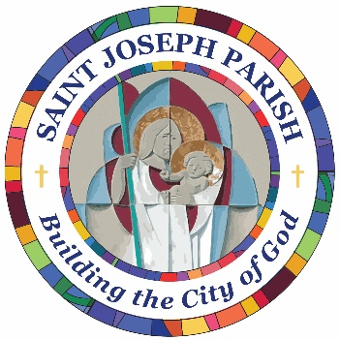

Now Thank We
All Our God


With Heart
and Hands
and Voices

Ronkonkoma Thanksgiving Service
Tuesday, November 25, 2025

